MAZE SOLVER ROBOT

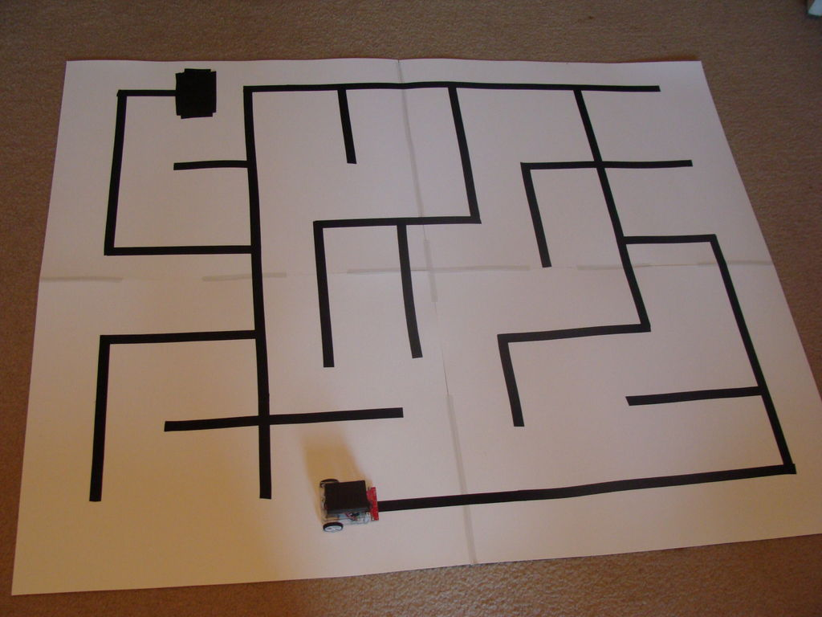

*BY:-*

|  |  |  |
| --- | --- | --- |
| **NAME** | **ROLL NUMBER** | **BRANCH** |
| ADARSH ANAND | 101715007 | ENC |
| AMAN ARORA | 101706 | ECE |
| HIMALAYA KATHPAL | 1017150 | ENC |
| PRANAVI JAIN | 1017151 | ENC |

**Acknowledgements**

We are highly indebted to our seniors cum mentors at IETE Students’ Forum for their guidance and constant supervision as well as for providing necessary information regarding the project and for their support in completing the project.

With sincere thanks,

Adarsh Anand

Aman Arora

Himalaya Kathpal

Pranavi Jain

**Table of contents**

1. Acknowledgement………………………………….………………

2. Table of Contents……………………………………………………

3. Introduction………………………………………………………..….

4. Problem Description and Proposed Solution……….….

5. Modules used in this system………………………………..…

6. Approximate budget……………………………………….………

7. Application of systems……………………………………………

8. Advantages of system…………………………………………….

Introduction